**

**Geldmaat User Stories**

**Semarchy xDM**

www.amplifiuk.com

+44 (0) 1926 911820

Third Floor, Marlborough House

48 Holly Walk, Leamington Spa

CV32 4XP, United Kingdom

# User Story 1 – Cash Point

As a Geldmaat Change Desk User I need to be able to deactivate one or multiple Cash Points. I would also need to be able to create one, or multiple Cash Points.

**Workflow 1: Deactivate (replace) 3 cashpoints and create 3 new cashpoints in its place.**

The below screens cannot be opened outside of Geldmaat, so they are for us to click through.

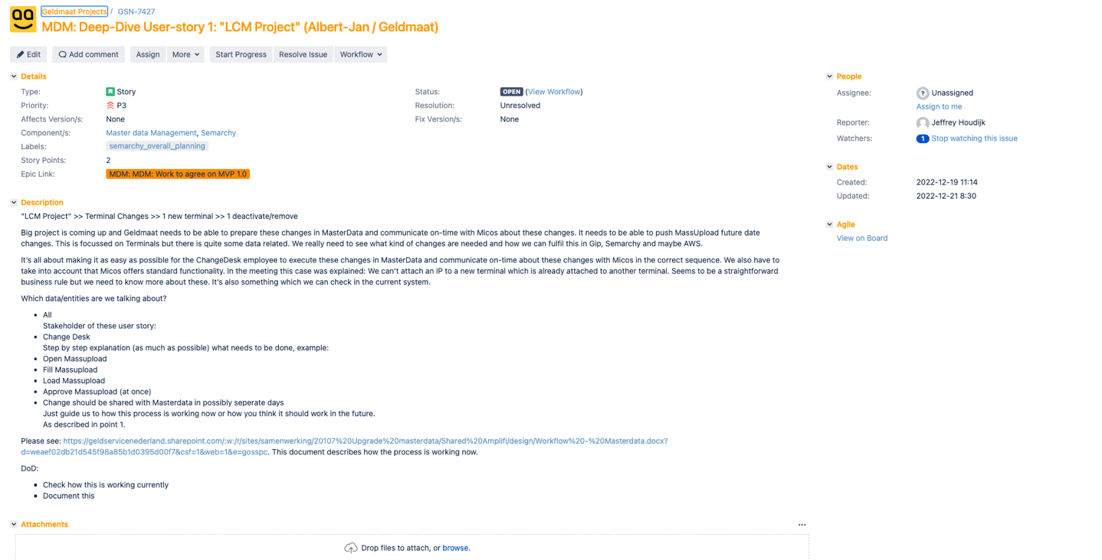

# User Story 3 – Mass Changes to Timetables

As a Geldmaat Change Desk User I need to be able to upload future versions of a Locations timetables.

**Workflow 3: Update multiple timetables**

For this workflow the changedesk manager has to change the timetables on locations for multiple locations.

They would like to be able to change them as easily as possible.

**Process 1:**

Change the openinghours of all the locations starting with 9401.

Select all the openinghours of Friday and update them to open at 06:00:00 instead of 7 or 8 AM.

The openinghours should start as of next week (17-01-2023).

**Process 2:**

For reference try to mass update these records by Excel. 

**Process 3:**

After process 1, the friday openinghours of the location 9401005 should be 05:00:00 the week after the previous change.

Then also add one for 7:00 a week later and another one for 08:00:00 a week after that. So you have 4 pending changes on that location for the Friday timetable a week apart.

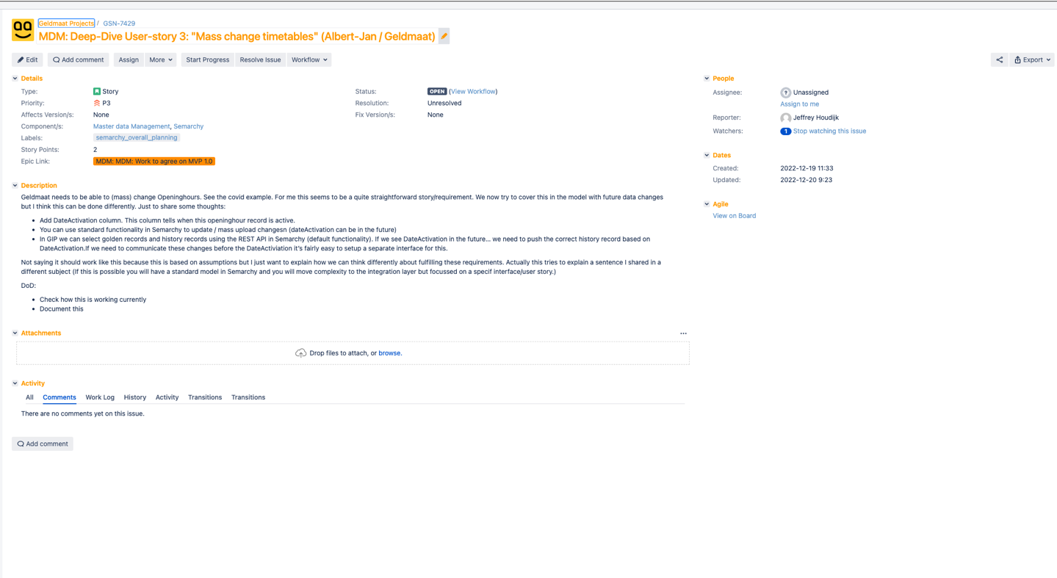

# User Story 2 and 6

As a Geldmaat Change Desk User I need to be able to create a new Terminal, meaning that I need to either create or select a Cash Area and subsequently create a Location, Address and one or many Cash Points.

**Workflow 6: Create a new location with 3 cashpoints**

Added in the attachment an example of a location with 3 cashpoints. The setup is based on the old masterdata so the data still has to be split up, but all the fields are there.

Let me know if you need any translations.

Please show how to create a new location and add 3 cashpoints. The process will probably be as follows:

1. Check is a CashArea is available (create a new one)
2. Create a new address
3. Create the location
4. Add the Router
5. Add the TimeTables
6. Add the Cashpoints
7. Add the terminals
8. Add the serviceparties

Please have some thought on the businessrules that have been modeled. So the CashArea has to be communicated before the location and the location has to be communicated before the Cashpoint/Terminal.

Also some types (ATM) require cassettes. The example in the attachment doesn’t have an ATM. But the serviceparty Vendor has to be present for example. A router needs to be on the location when terminals/cashpoints are added (a check if the IP addresses are correct and fall in the range of the router AND the ip has to be unique on the location).

1. Creation or changes on **CashArea** are always done via GUI and not via MassUpload
2. Creation or changes on **Location** are always done via GUI and not via MassUpload
3. When a shop is **moved** to another location this is what they do:

* First put on a deviation on the CashPoint so it gets out of servicing and maintenance
* Create a new location (this is only done when the zipcode changes, otherwise they will only change the address)
* Change several items on the location when necessary, such as router
* Sometimes the terminal is stored somewhere else during the move
* After the move the CashPoint-ID is re-used (ID remains the same) and when a new location is created they will change the location for this CashPoint
* Put an end-date on the deviation and (re)activate the CashPoint

1. For **LCM** they will add the changes **2 weeks** up front, so the end-date of the old CashPoint is set and a new CashPoint is created with an activation date on the same day as the enddate of the old CashPoint. Replacements will be done on one day.  
   from my experience it gets nasty when the planned date is changed…
2. A lot of question go round at the ChangeDesk concerning the retailers **holidays**… this might be solved within Micos using a deviation

Create or Amend:

Cash Area >

Location > Address > Router > Location Timetables > Location Service Parties >

Cash Point > Cash Point Groups

Terminal > Terminal Cassette

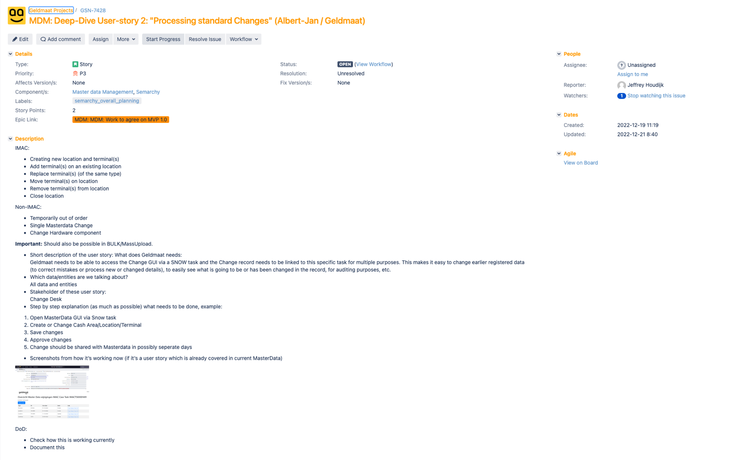

# User story 4 – Transport Code

**Workflow 4: Update the transportcode for 5 terminals**

Dataset:

|  |  |  |
| --- | --- | --- |
| CashPointID | Old Transportcode | New TransportCode |
| 914871 | I83632 | I93633 |
| 914865 | K85347 | K95345 |
| 914872 | I83633 | I93633 |
| 914864 | N87533 | N97537 |
| 914867 | G82217 | G92212 |

Please show how we can optimally update multiple cashpoints/terminals and change the transportcode fields. Including a startdate in the future. (dateactivation is a field used inside of Micos btw so we shouldn’t use that field as a future record type date).

